【Detailed version】 for "XIth Congress of the International Society for Dialectology and Geolinguistics (SIDG)".

Keywords: river names, hydronym, East Asian languages, Japanese, Geolinguistics.
Title;
Distribution of River Names (Hydronym) in Japanese and East Asian Languages and Their Geolinguistic Interpretation
Seiya ABE
Gakushuin University, Japan; 20030101@gakushuin.ac.jp
Abstract;
By investigating the distribution ranges of Hydronym as for river names and watercourses in Japanese, Ainu language, Korean and East Asian languages from a geolinguistic perspective, we can reveal the ancient distribution and the historical sequence of influence from East Asian languages on Japanese Dialects.
**************************************************

Distribution of River Names (Hydronym) in Japanese and East Asian Languages and Their Geolinguistic Interpretation
Seiya ABE Gakushuin University, Japan

20030101@gakushuin.ac.jp https://www-cc.gakushuin.ac.jp/~20030101/
Affiliation ; Department of Literature (Japanese Linguistics) in Gakushuin Univ. in Tokyo.

Note: I am afraid that some I.P.A. characters get loss or change during transmission by E-mail or printing for publishing. So please confirm them by my original Japanese thesis if you have some question about each word form.

１ East Asian Languages and the Monsoon Asia Region

  - Historic Research on East Asian Languages and the Monsoon Asia Region

Genealogical origins and relations of East Asian languages—including the Japanese language—remains unclear even in the light of latest findings in linguistic research worldwide. Languages of concern in this study, namely, Japanese, Korean, Ainu, and Palaeo-Asiatics all belong to this group of languages with unknown origin.
This gap in research findings can be attributed to several factors. First, compared to their Indo-European counterparts, there remains much less linguistic materials left of these East Asian languages. Another reason is the fact that the only comparative linguistic approaches, which have been valid approaches to study Indo-European languages, have been applied to East Asian languages. The approaches that have been useful for the study of Indo-Europeans may not be equally valid for the study of East Asian languages. Rather, the long and complex history of the East Asian region calls for new approaches to the study of languages spoken within its boundaries.
The present study proposes one such new approach to the historic linguistic research on East Asian languages from the viewpoint of the stratificational model.
Research based on the stratificational model can be defined as a geolinguistic and typological analysis of linguistic features of various languages spoken within a particular region (Mainhof and van Warmelo, 1932). The approach also aims to clarify, as much as possible, differences in chronological age, geographical limits, and factors which contributed to similarities and differences among those languages.
According to Abe (2002. 5), the stratificational approach:

- employs research methods of dialectology and geolinguistics.
- considers all different levels of strata which consist of several different languages with different origin and / or relations.
- describes languages, not only in terms of the absolute time in years, but also in terms of relative historical markings.
- describes the entire linguistic history of the region more concretely—as a complex phenomenon with various linguistic features (e.g., grammar, phonetics or lexicon) by different historic stages.

As illustrated in this paper, this stratificational model of language evolution can help explain typology and distribution patterns of East Asian languages and suggests the possibility that a number of common features were widely distributed throughout the region at a fairly early stage in history.
Of all common features, the most prevalent are the distribution of names for various forms of Hydronym (including names of swamps and marshlands, hereafter “Hydronym rivernames”) and that of classifiers throughout the region. Regional similarities found in these two types of distribution seem to indicate common features in Asian languages that date back to early times in history.
Furthermore, the distribution patterns of these linguistic features throughout the region seem to suggest the existence of the “Monsoon Asia Cultural Sphere” as one of factors contributing to the formation of the linguistic substratum (Abe, 2003.7).

●The “Monsoon Asia Cultural Sphere” as the background for distributions of rivernames, classifiers and myths.
- Aikhenvald, Alexandra Y. (2000). Classifiers. Oxford University Press.

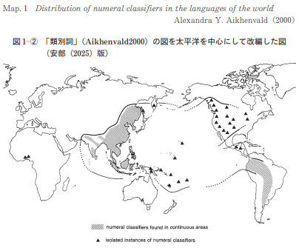
1-2. Distribution patterns of classifiers

Classifiers are a type of linguistic phenomena widely observed in the Asia-Pacific region (Aikhenvald, 2000, Map 1). It remains unclear why the phenomenon is found in this particular geographical area. Yet it may suggest a possibility that it resulted from a certain linguistic distribution within this region. That is because, as will be discussed in the section that follows, many other types of shared cultural-anthropological phenomena are found in this area.

- Map 2 : “Monsoon Asia Cultural Sphere” and Altaic Language area. By ABE 2005
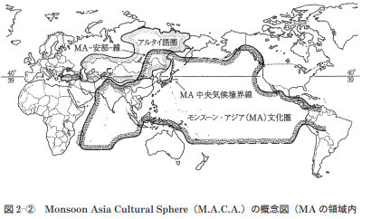

1-3. Distribution Area of Mythology
- Eastern mythology（Frobenius, 1938）
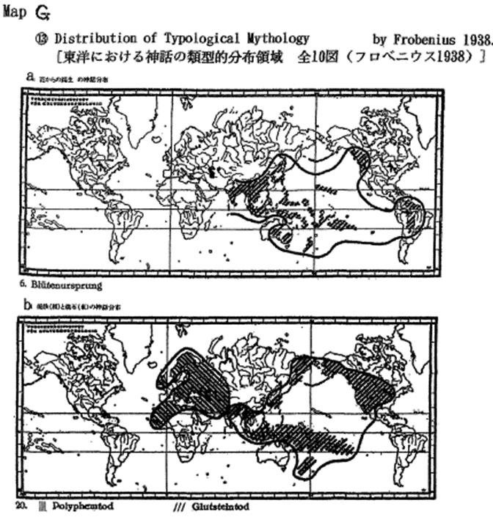

Distribution patterns of mythology play a particularly important role in geolinguistic research as it is transmitted through language. As indicated by Frobenius (1938), unique patterns exist for distribution areas of various myths in Asia. MAP G (a & b) hows two of the ten atlas of mythology distribution in the East by Frobenius (1938). It is remarkable that these areas of distribution closely overlap with that of classifiers presented above. It is intriguing to note that both areas cover South and North-East Asia and reach the Pacific and the Pacific Rim regions.
Of course, these overlapping areas of distributions do not directly prove language similarities. Yet when the fact that various myths can spread geographically only by means of language, it thus seems to suggest the existence, at a very early stage in history, of a common cultural basis for linguistic diffusion.

2. Rivernames: their forms and distribution patterns in East Asia

2-1. Significance of rivernames in geolinguistics

It has been pointed out that studying rivernames is one of the best approaches to geolinguistic research on a considerably wide geographical area.
According to Krahe (1954), it has been proven that, of all proper names, rivernames are the oldest and boast the longest continuity. Krahe (1954) further argues that rivernames, thanks to their above-mentioned unique characteristics as linguistic material, best help shed light on ancient civilization, and migrations within the European continent.
Further, Schostakowitsch (1926) identifies unique patterns in word-endings of Siberian rivernames and argues that the pattern derive from an ancient language which once was used by a vanished ethnic group who lived in the region.
Based on these studies of European languages, Kim (1983) studies the genealogy of the Korean languages. As a way of illustrating differences among the Kokuryo language of the Northern Korea as well as Southern Korean languages of Pekche and Silla, Kim (1983) reports different rivernames used in these three languages in old Korean Peninsula.
Likewise, Abe (2001.11, 2003.7, 2003.7.29, 2004.7) found that rivernames which supposedly evolved from the same etymons as the rivernames in the Japanese language are widely distributed throughout East Asia. Abe’s recent work (2004.7, 2005.5, 2025a & 2025b), including this article, follows the aforementioned studies on European and Siberian rivernames and is the first to identify patterns of rivername distributions all across Asia.

2-2. Distribution patterns of a rivername, “*nahdi”

A common word form is found in rivernames in Japanese, Korean, Tungus, Chinese, Gilyak and Mundari. In addition to these East Asian languages, rivernames in Austro-Asian languages such as Dravidian and Munda in South Asia as well as in Turkish in West Asia share common word form. As such, it can be safely assumed that all of these rivernames evolved from a common etymon, most likely, “*nahdi, “early in history.

○East Asian Languages <*nahdi
Japanese | na (Old Japanese; cf. ABE 2004. 7)
Japanese | nai (Ryukyuan Dialect；sonai, pinai)
Japanese | nai (Tohoku Dialect ; nai, sappinai)
Japanese | nati (river name; nati river )
Chinese | nai, nei, ner, ndei (ancient CHN.) ＝濘・泥
Korean | nari, naih, nʌrʌ, *nai, *na (nє : modern Korean)  (Middle & Old Korean, and Korean Dialects)
Tungus | Nā
Gilyak | *nalu,nállu,ŋalu, (ńayu for a small river , ńallo for a small bay.[ń] means [n] have‘˙’mark over it.)
○South Asian Languages <*nahdi
Mundari (Munda) | nāi (a big river, from Bhaduri’s A Mundari-English Dictionary) .
Santáli (Munda) | nái (Hunter,1978); nãi (a river, from Campbell’s English-Santali Dictionary)
Santáli ( Munda) | nala, nali, noli (stream, ditch, from A Comparative Study of Santali and Bengali) .
Sávara (Munda); | náyi
Kurumba (Dravidian) | nirú
○West Asian Languages (Altaic Languages) <*nahdi (cf. *nahdi>Naiad)
Turkish | nehir [ nєhíɹ]

- Distribution patterns of a rivername, “*nahdi”
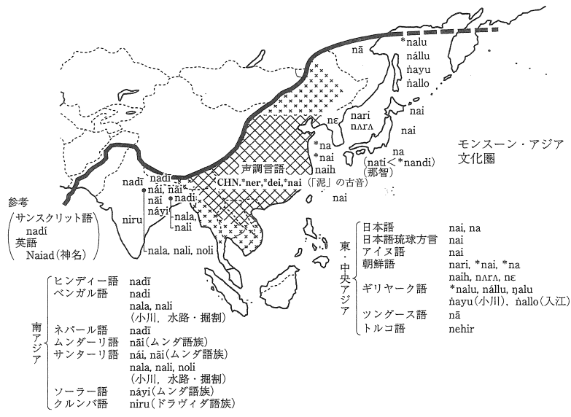
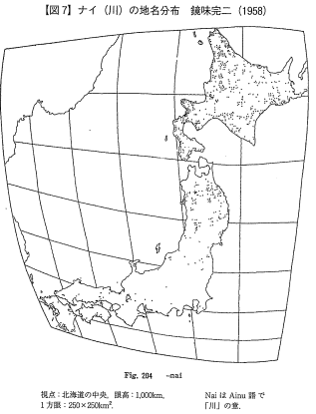

2-3. Distribution patterns of a rivername, “*səngay

- Distribution patterns of small river, “*səngay
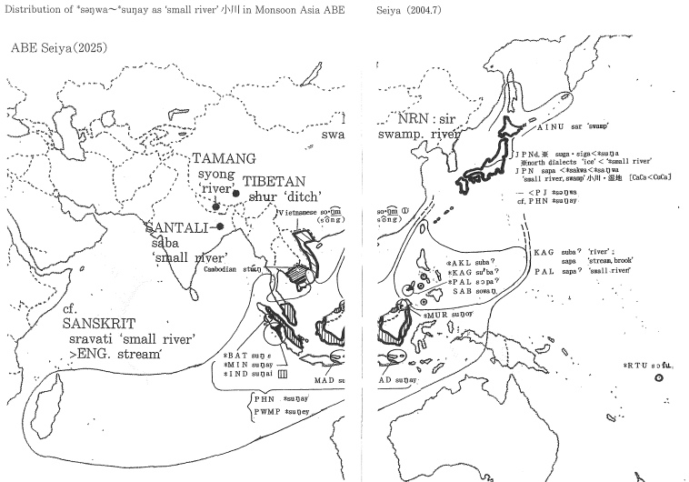
“Sawa” is a Japanese word that stands for a brook or a swamp. In addition, there are several place names in Japan, all of which concern river or water, that are considered as to have derived from the same etymon as “sawa”: Suwa, Singa, Sungoo (<sungau<sungaɸu<sungapu, ng=ŋ). From these derivatives, a common etymon, “*səngwa” (or *sungwa) can be assumed. Proto-Japanese (PJN) “sapa, saba“ & ”*səngwa (or *sungwa)”

Rivernames in the Ainu, Korean, Austronesian, and Austro-Asian languages that presumably derived from the same etymon as the Japanese words above are as follows (cf. ABE2004.7 & 2004.12).
Ainu | sa (river sides, plain, Batchelor’s Dictionary)
Ainu | sar(*sar・ga<*sanga, swamp, from Slawick)
Ainu | sara (A plain covered with a kind of sedge, Batchelor’s Dictionary)
Korean | sir<*sər (small river in "Sangoku-Iji")
Naanai (Tungus) | siru<*sər (sand)
○Austronesian; rivername
①*AKL (Aklanon) | subaʔ
*PAL (Palawan) | sɔpaʔ
*KAG (Kagayanen) | súbaʔ
SAB (Bangingi Sama) | sowing
②*MUR (Murut (Timugon)) | sungoy
*BAT(Batak Toba) | sungε
*MIN (Minangkabau) | sungay
*IND (Indonesian ) | sungai
MAD (Madurese) | sungay
③*RTU (Rotuman) (Polynesian) | sɔfu
PHN (Proto-Hesperonesian) | sungay
PWMP(Proto-Western-Marayo-Polynesian) | sungey (cf. MGY=MALAGSY MERINA in Tryson 1995)

The Austronesian word form described above is documented in Tryson (1995) also refers to the following word forms and meaning in its appendix.

①AKL | Proto-Southern Philioppines *subaʔ
PAL | sapaʔ(small river); sɔsapaʔ(stream, brook)
KAG | subaʔ(river) ; sapa (stream, brook)

Tryson (1995) cites “sungay” as a Hesperonesian etymon and “sungey” as a Proto-Western-Marayo-Polynesian etymon with similar genealogical origins.
In addition, it is highly likely that rivernames in the languages listed below (Tibetan, Vietnamese, Cambodian and Burmese, and Tamang of the Tibeto Burman from the Sina-Tibetan language family) are also related to the “sungay” etymon. Thus, the geological relations between the “sungay” etimon and its possible derivatives in these languages should be examined in future research.

Tamang (=Murmi) | syong (for river), Hunter (1978)
Tibetan | shur (ditch), by Kitamura・Nagano1990
Vietnamese | song [so・ŋm ①] (river)
Cambodian | stɯŋ ［ɯ =ɯ＋′］(river)
Burmese | khyong [chauN:] (river)

Furthermore, a “sungay” derivative in Santali (one of the Mundari langugaes which belongs to the Austro-Asian language family) is saba. It can be assumed that this “saba” evolved from the same etymon as did other derivatives in East Asian languages. The examples from those languages are repeated below.

Santali | saba (small river), by Campbell’s English-Santali Dictionary.
 | cf. Japanese; sapa, *saba (small river, swamp)
 | (cf. *səngway>*savay>sravati (SKT)>stream (English)
PAL(Palawan) | sapaʔ (small river)
KAG(Kagayanen) | sapa (stream, brook), subaʔ(river)
 | cf. AINU; sar (swamp)

Though these language originate from places far away from one another, all of these derivatives share the vowel, “a (or ə)”. The evolution of rivernames in this partcular language group can be assumed as:
*saba<*sagwa < (*sar<*sargwa)<*sangwa <*sangway (or *səngway)

As illustrated below, the “səngay” derivatives are distributed as far as Austro-Asians in India, Austronesians in the Pacific region, and Japanese and Ainu in north eastern Asia. Of these languages, the close relation of Austronesians and Ainu has been pointed out by Murayama (1993).

2-4. Distribution patterns of a rivername, “*nub” (for swamp; cf. Abe, 2005.5)

- Map: Distribution patterns of “*nub” (for swamp, mud, black)
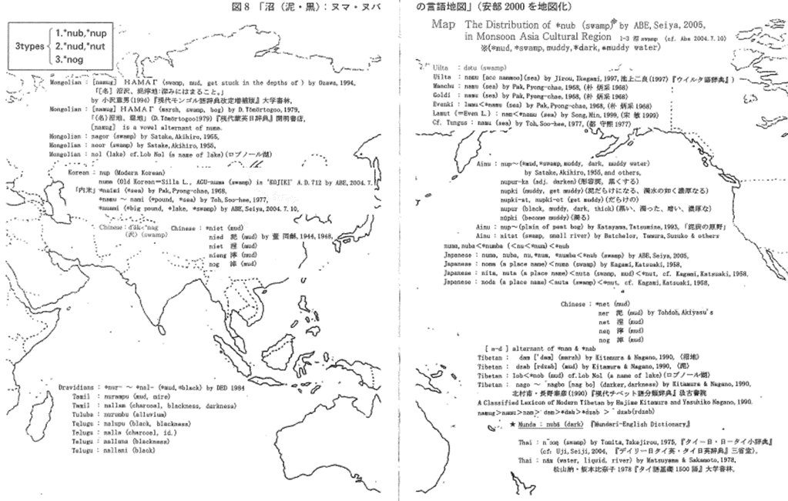
Words that refer to swamps and wetlands are also widely distributed throughout Asia (Abe, 2005.5). For instance, Japanese has three such words, “numa” in modern Japanese, as well as “nu” and “nuba” both of which were in use during the Nara period.
“M” and “b” in those swamp-related words are phonetic allphones and as such, are interchangeable. Given similarities and differences in word forms of these three words, the following process of linguistic evolution can be assumed (Abe, 2005.5).
Japansese | *nub>*numb(>*num>nu),>*numba>nuba/numa, ( swamp, mud, dark) (Abe, 2005.5).
Ainu | nup-（*mud, muddy water）
Ainu | nupur-ka (adj. blacken)
Ainu | nupki (wear mud, thick as muddy water)
Ainu | nupki-at, nupki-ot (mud all over )
Ainu | nupur (black, thick, dark), by Satake, 1955.
Ainu | nup-, (peat moor) by Katayama, T. 1993.

In addition, in the Ainu language, there seems to exist “*nup-” a common morpheme for words that refer to “swamp, ” “black” or “muddy water” (Satake, 1955. cf. Abe, 2005.5). There is also another interpretation that “nup” stands for “peat moor” (Katayama, T., 1993). Taken altogether, nup- is used for mud, peat, wetlands, all of which are closely related to swamp.
Ainu; nup- (swamp, mud, wetland, muddy water)
In Korean, nɯp stands for “swamp.” “Numa” is also documented as part of a placename—“agu-numa” in Silla, the ancient Korea—in the Japanese “Kojiki.” (Abe, 2005.5).
Korean; nɯp, Silla language, 'agu-numa'
In Mongolian, to give yet another example, “namug” exists as a word to refer to marsh, swamp or bog (Tӧmӧrtogoo, 1979), . This “namug” can be interpreted as a vowel alternant of “numa” (Abe, 2005.5).
Mongolian ; ＨＡＭＡΓ[namug], n. marsh, swamp, bog.(D.Tӧmӧrtogoo, 1979）
In Tibetan, too, a possible n-d alternant of “numa” exists.
Tibetan: ΄dam (‘dam) for marsh (Kitamura & Nagano, 1990).
Tibetan: ^dzab (rdzab) for mud (Kitamura & Nagano, 1990).
When seen as n-d alternants of “numa, ” the word, “dam” can be taken as”nam, ” a form which closely resembles “namug” in Mongn (Abe, 2005.5).
namug>namu>nam>‘dam (>*dab) >dzab (rdzab) (cf. *num >dim (dark))

Further research has found words that resemble “nam-” and “dam-” and stand for “sea” (which is closely related to swamp) in Uilta, Manchu, Goldi, Evenki, Lamut, all of which belong to the Tungus languge family.

Uilta | namu [acc. nammoo] (sea) (cf. dətu ( for swamp))
Manchu | namu (sea）(Pak, 1968)
Goldi | namu (sea）(Pak, 1968)
Evenki | lamu<*namu (sea) (Pak, 1968)
Lamut (=Even); | nam<*namu (sea) (Song, 1999)
 | cf. Tungus; namu (sea)(Toh, 1977)

“Namu” and its derivatives in these languages seem to have evolved from the same etymon as did “namug” (swamp) in Mongolian and “dam” (marsh) in Tibetan, given their close resemblence in both word forms and meaning. With these words, the referent “swamp” changed into “ocean” as those language were mainly used in inland areas where there is no ocean and where other forms of big bodies of water such as lakes and swamps must have been understood as “the ocean.” Assuming that, the following continuum of evolution seemed to have existed in the region:
numa ‘swamp, bog’⇔namu～ ‘swamp、marsh, bog、mud’⇔namu ‘sea’
As discussed above, a wide variety of “numa / nuba” derivatives that stand for swamp or ocean exist in East Asia.
Let us now turn to South Asia. Mundari (an Austro-Asian language), has a word, “nuba” for black, which shares a meaning with（<*nub、as for swamp, mud, black）“nup” in the Ainu.
Munda ; nuba (dark) “Mundari-English Dictionary”

It is worth noting that Austro-Asian languages such as Mundar has such a cognate word: it seems to suggest the same East-South Asia diffusion pattern as with “nahdi” and “sungay.”
This section reviewed distribution patterns of rivernames, *nahdi, *səŋay, *nub” in Asia and illustrated how cognate words exist in languages used in Northeastern Asia (i.e., Japanese, Korean, Ainu and Tungus) and those spoken in South Asia (i.e., Austronesians, Austro-Asians, Dravidians).

- Figure 1.10: Suffixes in names of lakes and wetlands -ike and numa (From Kagami 1958: 18).
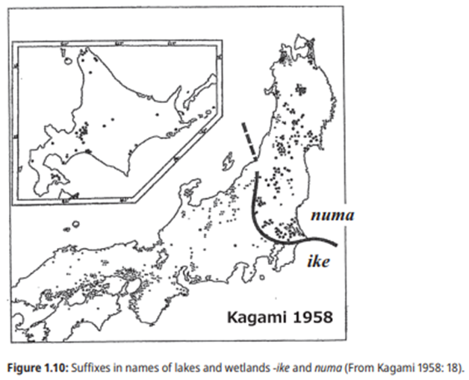

- Figure 1.11: River names with the suffix -tani (Original map: Kagami 1958: 14 [From Suzuki 1978: 135]).
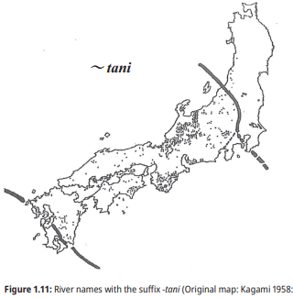

- Map: Distribution patterns of “*jat~”(lesft side) and “*sapa, saba“ (right side)
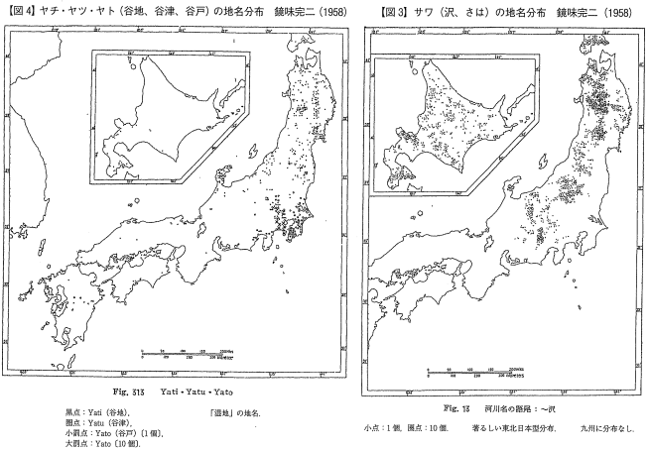
■FROM ABE 2006
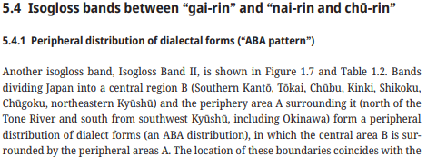

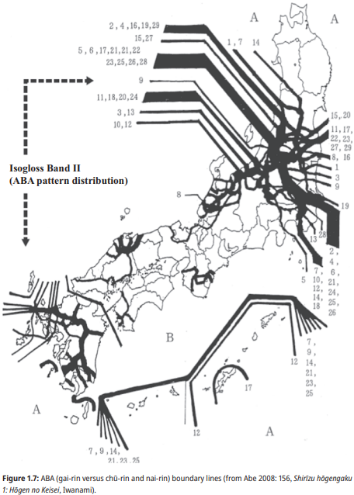

- Map D: CHOPPING TOOLS IN PALEOLITHIC ERA ( EAST : NON-BI-FACES)
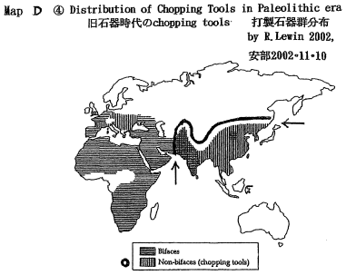

■FROM ABE 2006
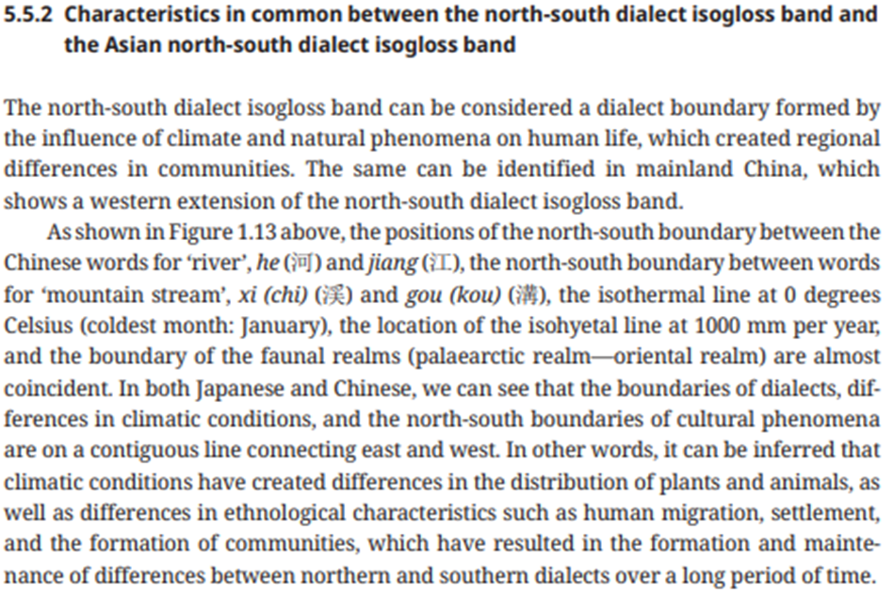

- Map COMPOSIT BORDERS OF LANGUAGES OF LANGUAGES, CULTURE AND CLIMATE IN ASIA (from ABE 2013)
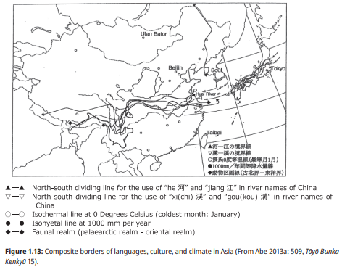

- Map COMPOSIT BORDERS OF LANGUAGES OF LANGUAGES, CULTURE AND CLIMATE IN EUROPE from ABE 2013)
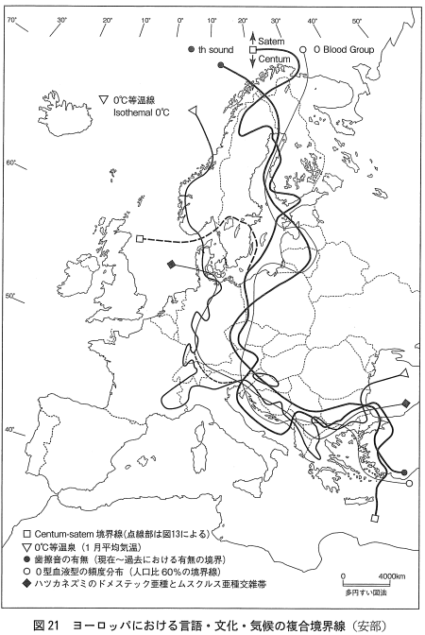

４. The “Monsoon Asia Substratum” and the Altaic Superstratum
This paper has examined the study of Japanese and East Asian Hydronym.
The section above argues for the existence of a cultural substratum in the Monsoon Asia region. Considering this substratum as well as overlapping areas of rivername and classifier distributions, both of which form significant parts of the basic vocabulary in any language, it can be assumed that a linguistic substratum was once formed in this region at some point in history. The substratum, in turn, has evolved into different languages in different regions, eventually turning into various language families and / or languages of unknown origion in the Asian Pacific region. As such, this hypothetical linguistic substratum should help explain the developmental process of the Japanese and Korean languages as follows.
As for Korean, a language closely associated with the Altai, the most convincing of all existing theories for its formation is that of Kim (1983): Though Korean belongs to the Altai family, it is highly likely that the language has been influenced another, non-Altaic substratum or a language prevalent in the ancient Korean Peninsula. Yet, this non-Altaic substratum has remained unidentified in previous studies. Now, the “Monsoon Asia” substratum can be assumed the same as the “non-Altaic substratum” Kim (1983) advances. If so, it can be argued that the Korean language is based on two layers of linguistic strata: the Monsoon Asia substratum and the Altaic superstratum.
The origin and formation of the Japanese language can be explained similarly. One of the strongest existing genealogical explanations for Japanese is the one that it is based on two linguistic layers, one of the languages distributed in the south of Japan at the bottom and an Altaic language such as Korean on top.
Language / Strata | Subsutatum | Intercalary Stratum | Superstratum
Japanese | *Proto-MA languages | Austronesian | Altaic Language
Korean | *Proto-MA languages | × | Altaic Language
This hypothesis nicely accounts for the fact that Korean has little influence of Austronesian while Japanese has the following three linguistic features only shared with Austronesian: a) a 4-vowel system (found in ancient Japanese); b) open syllabic structure, c) common basic vocabulary (especially in words for body parts). These similarities suggest that Japanese has been strongly influenced by Austronesian, apart from its Monsoon Asia substratum.
The claim advanced here is a new and unique one in that it can explain similarities and differences between Korean and Japanese using the Monsoon substratum and the Austronesian intercalary stratum. In Map 2, boundaries of the Monsoon Asia substratum and the Altaic superstratum in Korean Peninsula and Japanese Archipelago are indicated.

References
Abe, Seiya. 1998. Nihon rettō no rekisi to bunka ni okeru mō hitotsu no tōzai tairitsu kyōkaisen “Kantō-Echigo-sengun”-“Kō-nihon Naka-nihon tairitsu bunpu” [Another east-west boundary line in the history and culture of the Japanese archipelago: The Kantō-Echigo isogloss bundle—Kō-Nihon—Naka-Nihon contrastive distribution]. Ferisu Jogakuin Daigaku Kiyō 33. 1–31.
Abe, Seiya. 1999. Nihon rettō ni okeru mō hitotsu no hōgen bunpu kyōkaisen “Kikō-sen” [Another dialect boundary line in the Japanese archipelago: the “Climate Isogloss Bundle”]. Tamamo 35. 29–37.
Abe, Seiya (2001.11).On the relationship between the distribution of the name of rivercourses in East Asia (Japanese, Korean, Chinese) and the Climate in the region (2): Maps and Supplements [Higasi Asia no kasen chimei no henzai to hougen bunpu・kikou tono soukan; hosetsu ], Tamamo, 37, pp.1-11,
Abe, Seiya (2002.5). On the formation of Japanese language from the viewpoint of ‘Stratification Model’ [Hogen Chirigaku kara mita Nihongo no Seiritsu: dai 3 no Gengoshi Moderu Riron toshiteno ‘Stratification Moderu’], Hogen Chirigaku no Kadai, pp. 262-276, Meiji-Shoin, Japan.
Abe, Seiya. 2003. Kantō ni okeru Nihongo Hōgen kyōkaisen kara mita kasen tikeimei no jūso to sono haikei [The Overlapping Distribution of Various Terms for Rivercourses and Its Background Considered from the Point of View of the Dialectal Borderline in the Kantō Region]. Studies in the Japanese language 54(3). 101–116.
Abe, Seiya (2003.7.29). Dialectical / climatic features and distribution of terms for watercourses in Asian languages: the case of Japanese, Korean, and Chinese. Proceedings of XVII international congress of linguists in CD-ROM, Prague, CIL.
Abe, Seiya (2004.7). Place names and Japanese—Linguistic sphere of rivernames, “Kokubungaku kaishaku to kanshou”, vol. 69-7.
Abe, Seiya. 2006a. Ajia to Nihon-rettō ni okeru gengo, bunka kyōkaisen “Kikōsen” (Sessi 0do sen) [A linguistic and cultural “climatic line” (0 degrees Celsius line) in Asia and the Japanese archipelago]. Gakushūin Daigaku Kenkyū Nenpō 52. 39–90.
Abe, Seiya. 2006b. On the “Monsoon Asia Substratum” and Altaic Superstratum in East Asia: A Stratificational Approach to Geolinguistics. In Guido Oebel (ed.), Japanische Beitrӓge zu Kultur und Sprache: Studia Iaponica Wolfgango Viereck emerito oblate [The Festshrift for Doc. Wolfgang Viereck, 79–96. LINCOM GmbH, Muenchen, Deutschland.
Abe, Seiya. 2008. Ajia no naka no Nihongo hōgen [Japanese dialects in Asia] In Takashi Kobayashi (ed.), Shirīzu hōgengaku 1: Hōgen no keisei [Dialectology Series 1: Dialect formation], 123–167. Tokyo: Iwanami.
Abe, Seiya. 2009. “Kitsu (ni hamenade)”: “Ise-monogatari (The Tale of Ise)”(Ch.14) no Nihongo hōgen oyobi Ajia gengo no naka no ichi [The geographical linguistic Interpretation of “Kitsu” of “Ise-monogatari (The Tale of Ise)” Ch.14 in Japanese dialects and Asian languages]. Kokubungaku Gengo to Bungei 125. 37–58. Tokyo: Ōfūsha.
Abe, Seiya. 2013a. Nihon oyobi Ajia gengo ni okeru ‘Nanboku hōgen bunpu kyōkaisen’ kara mita Indo-Yōroppa-go nidai bunpa Centum-Satem no kyōkaisen [The two great centum-sentum boundary lines in Indo-Euopean languages viewed from the perspective of north-south dialect boundary lines in languages in Japan and Asia]. Gakushūin Daigaku Tōyō Bunka Kenkyūjo: Tōyō Bunka Kenkyū 15. 540–491.
Abe, Seiya. 2013b. Nihongo no ‘Nanboku-gata hōgen bunpu’ kenkyū no tame no gengo-chizu ichiran [A summary of linguistic maps for the study of north-south dialect distributions in Japanese]. Gakushūin Daigaku Bungakubu Kenkyū Nenpō 60. 21–79.
Abe, Seiya. 2014. Nihongo no Nanboku-gata hōgen bunpu no chiri-gengogaku-teki kaishaku [Geolinguistic interpretation of the north-south dialect distribution in Japanese]. Gakushūin Daigaku Tōyō Bunka Kenkyūjo, Tōyō Bunka Kenkyū 16. 85–133.
Abe, Seiya. 2023. Hōgen kyōkaisen no ruikei to akusento bunpu to no sōkansei [A Study on the Correlation between Geographical Typology of Dialect Boundaries and Accent Distribution in Japanese]. Gakushūin Daigaku Bungakubu Kenkyū Nenpō 69.
ABE,Seiya,(2025b),The Classification and Division of Japanese Dialects, The Handbook of Japanese Dialects, Kibe, Nitta and Sasaki edit., De Gruyter Mouton, Berlin.pp.19-54.
Abe, Seiya. 2025a. “水名（河川名）「サワ」（沢）「シガ」（氷）小考：オーストロネシア語は2度列島をうるおす” [“A Note on the Hydronyms ‘Sawa’ (沢) and ‘Shiga’ (氷): On the Possibility of Two Episodes of Austronesian Influence on the Japanese Archipelago”]. Gakushuin Daigaku Kokugo Kokubungakkai-shi 68: (1)–(33).
Abe, Seiya. 2025b. “東アジア言語（日本語・中国語・朝鮮語）の南北方言におけるある種の音韻対応 [k・x-p]＜[*kʷ]” [“Phonological Correspondence [k/x-p] (< [*kʷ]) in the North-South Dialects of East Asian Languages (Japanese, Chinese, and Korean)”]. Jinbun 23: 7–46.
Abe, S. (2025.3c). Nihongo no kasenmei no jūsōteki keisei to monsūn ajia saiko kisō: Ōno Susumu-shi no indo e no shisen no saki ni aru mono [The Multi-layered Formation of Japanese River Names and the Oldest Substratum of Monsoon Asia: What Lies Beyond Mr. Susumu Ohno's Gaze Toward India]. Bungakubu Kenkyū Nenpō [Annual Report of the Faculty of Letters], 71.

Aikhenvald, Alexandra Y. (2000). Classifiers. Oxford University Press.
Chen, Cheng-Siang (1982). A historical and cultural atlas of China [ Chugoku Rekishi Bunka Chiri Zusatsu], Hara Shobo, Japan,
D.Tӧmӧrtogoo, (1979). A Modern Mongolian-English-Japanese dictionary [GendaiMou-Ei-Nichi Jiten]", edited by Kaimei Shoten, Tokyo,
Frobenius, (1938).Das Archiv fur Folkloristik, Paideuma, 1,
Hashimoto, J.Mantaroh (1981). Modern linguistics: Front lines of current linguistic studies [Gendai Hakugen Gaku], Taishukan Publishing, Japan,
Hunter, W.W. (1978). A Comparative dictionary of the languages of India and High Asia, Cosmo Publications, New Dehli,
Ikegami, Jiro (1997).A dictionary of Uilta, Hokkaido University Tosho Kankokai, Japan.
Kamei, Kono, & Chino (eds., 1989). The Sanseido encyclopaedia of linguistics, vol. 2, Sanseido, p.1751,
Katayama, Kazumichi (1996). A diffusion of Mongoloid to American Continet and Oceanean, The history of humankind [Jinrui-shi wo Tadoru], Asakura shoten, Tokyo,
Katayama, Tatsumine (1993). Japanese language and Ainu language, Suzusawa shoten, Tokyo,
Kim, Bang-Han, 1983). "The Genealogical Relationship of Korean Language [Kankokugo no Keitou]", Japan.
Kitamura, Hajime & Nagano, Yasukiko, (1990). A classified lexicon of Modern Tibetan, Kyukoshoin, Tokyo.
Krahe, H. (1954). Sprache und Vorzeit, Heidelberg.
Lee, Ki-moon, (1975). The history of Korean language [Kankogugo no Rekishi]", Taishukan, Tokyo. (1st ed. published in 1961, Korea),
Mainhof, C. & N. van Warmelo (1932). Introduction to the phonology of the Bantu languages, Berlin.
Murayama, Shichiro (1993) A Study of Ainu Language, San-ichi-shobo, Tokyo.
Pak, Pyong-chae (1968, 2001). A study on ancient Korean place-names [Kodai Sangoku no Chimei Goi Kou], Ancient Korean languages and North-Eastern Asia, Pek-san Saryo Woen, Korea, (originally published in 1968 in "Pek San Hak Po", 5)
Satake, Akihiro (1955). Characteristics found in color terms in ancient Japanese. Kokugo-Kokubun [Kokugo-Kokubun] 24-6.
Song, Min, (1999).Korean and Japanese in comparative perspective [Kankokugo to Nihongo no Aida], So-huu kan, Tokyo,
Savel’eve, V.N. & Taksami, C.M. (1970). Nivxsko-Russkij slovar, Moskva,
Schostakowitsch, W.B. (1926). Die Historish-ethnographishe Bedeutung der Benennungen sibirischer Fl¸sse. UJ, 6-1·2.
Shin-mura, Izuru, (1916). On the numeral of Japanese and Korean [ Kokugo oyobi Chosengo no Suushi ni tsuite], ”GEI-BUN”, 7-4.
Toh, Soo-hee, (1977). Study of the Pekche language [Kudara go Kenkyu], Asia Bunkasha, Soul.
Tryon, Darrell T. (ed.), (1995). Comparative Austronesian dictionary; an Introduction to Austronesian studies. Mouton de Gruyter, New York,

Appendix: Distribution Maps: ***************************

