【Handout at the presentation：Distribution Maps and list of river names】
SIDG "XIth Congress of the International Society for Dialectology and Geolinguistics (SIDG)" in Marburg, Germany. On September 7-11, 2026. [8th, Sep. 2026. 2:45pm - 3:15pm, Location: Seminar Building 201 (+2?0010).Sessin: Geolinguistics across Borders III,
Distribution of River Names (Hydronym) in Japanese and East Asian Languages and Their Geolinguistic Interpretation
Seiya ABE Gakushuin University, Japan; 20030101@gakushuin.ac.jp
Abstract;
By investigating the distribution ranges of Hydronym as for river names and watercourses in Japanese, Ainu language, Korean and East Asian languages from a geolinguistic perspective, we can reveal the ancient distribution and the historical sequence of influence from East Asian languages on Japanese Dialects.
Keywords: river names, hydronym, East Asian languages, Japanese, Geolinguistics, Historical Stratification of Japanese River Names
○waternames in English: river, stream, lake, swamp，pond, reservoir, sea, ocean, bay etc.
○Japanese waternames: Kawa＜*Kapa ＜*Kap, *ka(川 river＜）、Sawa ＜*sapa (沢stream）, Numa ＜*Nuba, Nu (沼, Swamp），Ike (池pond，貯水池reservoir, “Ike~” as for live, living ：「生」）、,Mizu-umi (湖, lake）、umi (海, sea, 海洋ocean）、wan (湾,bay）
◆Japanese Kawa 河川（＜峡）＜kapa＜* [kap̚] ←（Modern Korean 협 [çʌp̚]） ← Middle Korean 「峽」* [hjəp̚] ← Middle Chinese「峽」 [ɦˠɛp̚] ← Old Chinese「峽」 * [ɡˤrep] （ABE2026,this paper）

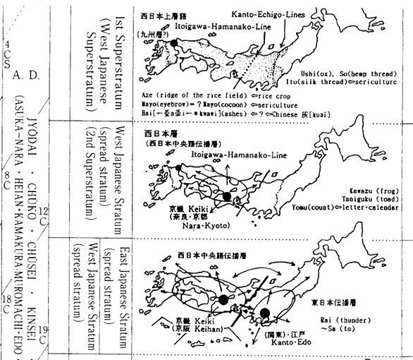
ダウンロード期限：LIMITED TILL 2026年12月9日(水) Contains ads upon scanning.

1，ウィーレック博士記念論集ー河川名分布ー安部清哉.pdf https://xgf.nu/oi5rS
2 木部先生ムートンテキスト安部1章The classification and division of Japan.pdf https://xgf.nu/uxVXC
3、Asia ＜＜音韻対応 河川名https://xgf.nu/rxc74
4、国語学54－3関東における sjl214101116cs https://xgf.nu/4npiw
5 Rivername, SAWA, SHIGA＜＜.202503安部河川名「サワ」さわ沢「シガ https://xgf.nu/rZuaf
６ NAI, TANI, SAWA, NUMA, YACHI, IKE etc. https://xgf.nu/CkN6G
7 Distribution of River Names (Hydronym) https://xgf.nu/jr3f4
８ Distribution of River Names (Hydronym) in Japanese and East Asian https://xgf.nu/MBRLZ
＊＊＊＊＊＊＊＊＊＊＊＊＊＊＊＊＊＊＊＊

- Introduction

2. The Earliest Possible Stratum: Southern and Monsoon-Asian Connections
2－0. Significance of rivernames in geolinguistics
In this section, the significance of studying “rivernames” in geolinguistics is discussed, followed by several examples of the rivernames found in Asia.
It has been pointed out that studying rivernames is one of the best approaches to geolinguistic research on a considerably wide geographical area.
According to Krahe (1954), it has been proven that, of all proper names, rivernames are the oldest and boast the longest continuity. Krahe (1954) further argues that rivernames, thanks to their above-mentioned unique characteristics as linguistic material, best help shed light on ancient civilization, and migrations within the European continent.
Further, Schostakowitsch (1926) identifies unique patterns in word-endings of Siberian rivernames and argues that the pattern derive from an ancient language which once was used by a vanished ethnic group who lived in the region.
Based on these studies of European languages, Kim (1983) studies the genealogy of the Korean languages. As a way of illustrating differences among the Kokuryo language of the Northern Korea as well as Southern Korean languages of Pekche and Silla, Kim (1983) reports different rivernames used in these three languages in old Korean Peninsula.
Likewise, Abe (2001.11, 2003.7, 2003.7.29 & 2004.7) found that rivernames which supposedly evolved from the same etymons as the rivernames in the Japanese language are widely distributed throughout East Asia.
Abe’s recent work (2013 & 2025.5), including this article, follows the aforementioned studies on European and Siberian rivernames and is the first to identify patterns of rivername distributions all across Asia.
Other studies on river names also support that researching river names and water-related vocabulary is useful for studying the history of a language.

◆Statement of the problem；What Historical Period Do Present-Day Place Names Reflect?
— The Chronological Stratification of Japanese Place-Name Distributions: Territorial Expansion of the Yamato Court and the Eighth-Century Linguistic Boundary

For data on the geographical distribution of place names, I use the atlas compiled by Kanji Kagami (1958). This work is regarded as one of the most highly respected sources for the geographical distribution of Japanese place names.
One of the most important problems in interpreting history on the basis of place-name distributions is determining what historical period the present distribution of place names reflects—that is, to what period the observed distribution can reasonably be attributed.
Regarding this question, I (Abe) propose the hypothesis that the distribution broadly reflects the place names of the first half of the eighth century. This hypothesis is based on two historical observations.
First, under the Taihō Code (Taihō Ritsuryō), the legal and administrative system established by the Yamato court in the early eighth century, place names throughout the country were reported to and recorded by the central government.
Second, in many areas there is a close correspondence between the geographical extent of Yamato court control around the eighth century and the uneven geographical distribution of place names that have survived to the present day.
In other words, during the first half of the eighth century, a nationwide survey and registration of place names conducted by the government appears to have resulted in local place names becoming established as officially recognized names. Within the territory controlled by the Yamato court, these place names consequently became relatively fixed. In areas that had not yet come under Yamato court control, however, place names were not fixed through this administrative process. Older local place names therefore survived there and were only gradually standardized or established at a later date.
For these reasons, the first half of the eighth century can be regarded, approximately, as a chronological boundary: within the territory of the Yamato court, newer place names became established, whereas in areas outside its control, older place names tended to survive.
The clearest example of this pattern can be seen in the geographical distribution of the river-name element “Nai”, “Numa.” “Nai” and ”Numa” are distributed primarily outside the territory controlled by the Yamato court in the eighth century. Within the territory under Yamato court control, by contrast, the form “Tani”and “Ike” are distributed instead. Thus, the geographical distributions of “Nai”, “Numa” and “Tani”,” “Ike” reveal a clear contrast between an older and a newer form.
：：：：：：：：：：：：：：：
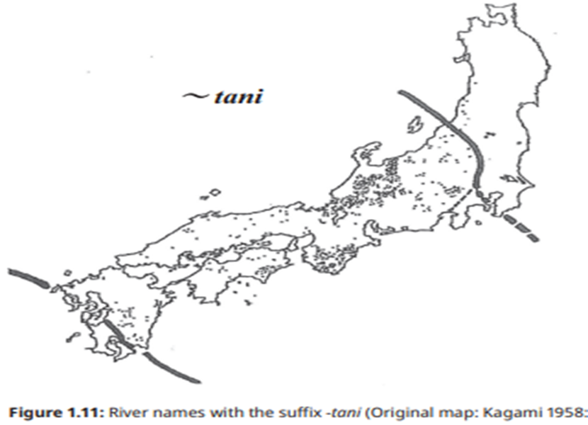
Appendix: The lists and Distribution Maps of rivername, (watername) :
１）rivername, “nai” ＜“*nahdi”
- Distribution patterns of a rivername, “nai” ＜“*nahdi”
○East Asian Languages <*nahdi
Japanese | na (Old Japanese; cf. ABE 2004. 7)
Japanese | nai (Ryukyuan Dialect；sonai, pinai)
Japanese | nai (Tohoku Dialect ; nai, sappinai)
Japanese | nati (river name; nati river )
Chinese | nai, nei, ner, ndei (ancient CHN.)＝濘・泥：river, mad.
Korean | nari, naih, nʌrʌ, *nai, *na (nє : modern Korean)  (Middle & Old Korean, and Korean Dialects)
Tungus | Nā
Gilyak | *nalu,nállu,ŋalu, (ńayu for a small river , ńallo for a small bay.[ń] means [n] have‘˙’mark over it.)
○South Asian Languages <*nahdi
Mundari (Munda) | nāi (a big river, from Bhaduri’s A Mundari-English Dictionary) .
Santáli (Munda) | nái (Hunter,1978); nãi (a river, from Campbell’s English-Santali Dictionary)
Santáli ( Munda) | nala, nali, noli (stream, ditch, from A Comparative Study of Santali and Bengali) .
Sávara (Munda); | náyi
Kurumba (Dravidian) | nirú
○West Asian Languages (Altaic Languages) <*nahdi (cf. *nahdi>Naiad)
Turkish | nehir [ nєhíɹ]

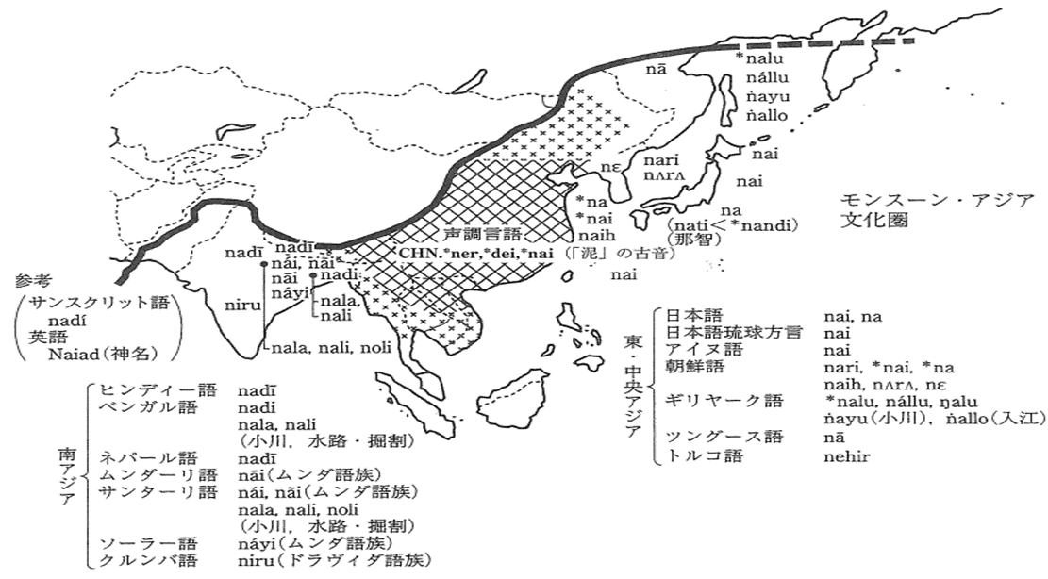

２）rivername, “sawa” ＜“*sapa” ＜ *saba, &,*sungey in Tryson 1995
Ainu | sa (river sides, plain, Batchelor’s Dictionary)
Ainu | sar(*sar・ga<*sanga, swamp, from Slawick)
Ainu | sara (A plain covered with a kind of sedge, Batchelor’s Dictionary)
Korean | sir<*sər (small river in "Sangoku-Iji")
Naanai (Tungus) | siru<*sər (sand)
○Austronesian; rivername
①*AKL (Aklanon) | subaʔ
*PAL (Palawan) | sɔpaʔ
*KAG (Kagayanen) | súbaʔ
SAB (Bangingi Sama) | sowing
②*MUR (Murut (Timugon)) | sungoy
*BAT(Batak Toba) | sungε
*MIN (Minangkabau) | sungay
*IND (Indonesian ) | sungai
MAD (Madurese) | sungay
③*RTU (Rotuman) (Polynesian) | sɔfu
PHN (Proto-Hesperonesian) | sungay
PWMP(Proto-Western-Marayo-Polynesian) | sungey (cf. MGY=MALAGSY MERINA in Tryson 1995)

The Austronesian word form described above is documented in Tryson (1995) also refers to the following word forms and meaning in its appendix.
①AKL | Proto-Southern Philioppines *subaʔ
PAL | sapaʔ(small river); sɔsapaʔ(stream, brook)
KAG | subaʔ(river) ; sapa (stream, brook)

Furthermore, a “sungay” derivative in Santali (one of the Mundari langugaes which belongs to the Austro-Asian language family) is saba. It can be assumed that this “saba” evolved from the same etymon as did other derivatives in East Asian languages. The examples from those languages are repeated below.
Santali | saba (small river), by Campbell’s English-Santali Dictionary.
 | cf. Japanese; sapa, *saba (small river, swamp)
 | (cf. *səngway>*savay>sravati (SKT)>stream (English)
PAL(Palawan) | sapaʔ (small river)
KAG(Kagayanen) | sapa (stream, brook), subaʔ(river)
 | cf. AINU; sar (swamp)

Though these language originate from places far away from one another, all of these derivatives share the vowel, “a (or ə)”. The evolution of rivernames in this partcular language group can be assumed as:
*saba<*sagwa < (*sar<*sargwa)<*sangwa <*sangway (or *səngway)
As illustrated below, the “səngay” derivatives are distributed as far as Austro-Asians in India, Austronesians in the Pacific region, and Japanese and Ainu in north eastern Asia. Of these languages, the close relation of Austronesians and Ainu has been pointed out by Murayama (1993).
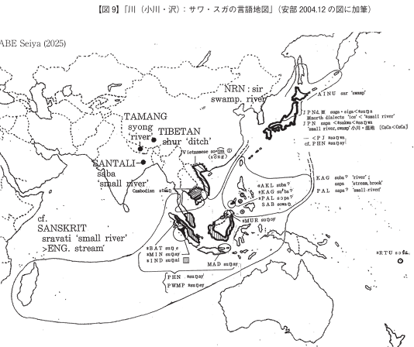
2-4. Distribution patterns of a rivername, “numa”＜“*nub” (for swamp; cf. Abe, 2005.5)
- Map: Distribution patterns of “numa”＜“*nub” (for swamp, mud, black)
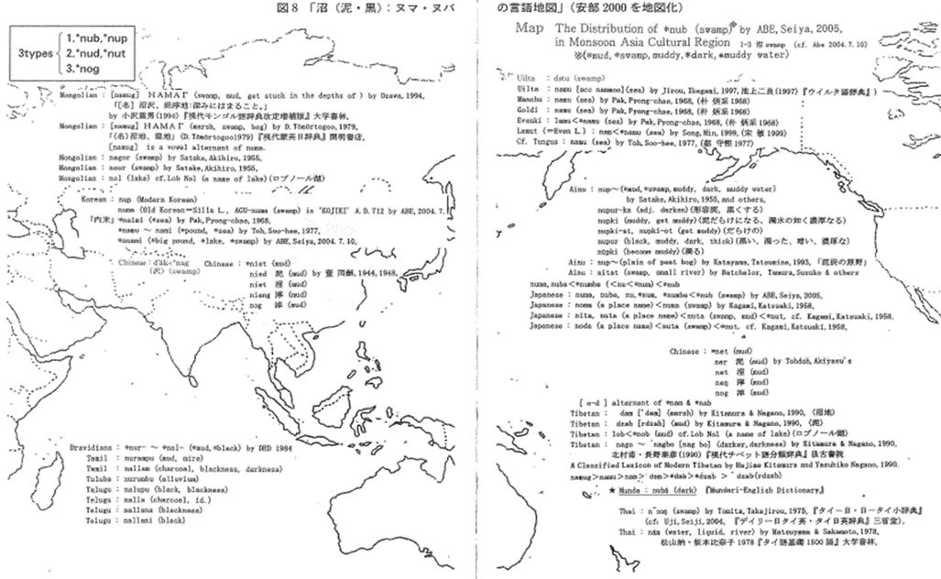

Japansese | *nub>*numb(>*num>nu),>*numba>nuba/numa, ( swamp, mud, dark) (Abe, 2005.5).
Ainu | nup-（*mud, muddy water）
Ainu | nupur-ka (adj. blacken)
Ainu | nupki (wear mud, thick as muddy water)
Ainu | nupki-at, nupki-ot (mud all over )
Ainu | nupur (black, thick, dark), by Satake, 1955.
Ainu | nup-, (peat moor) by Katayama, T. 1993.
Korean | Nup,
Munda

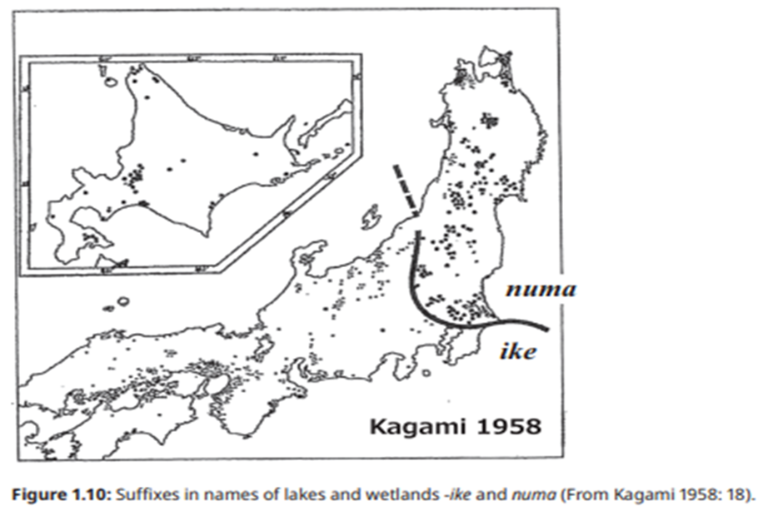
Figure 1.10: Suffixes in names of lakes and wetlands -ike and numa (From Kagami 1958: 18).

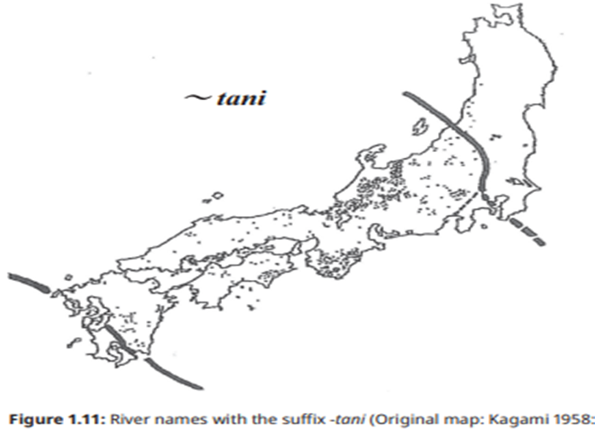

Map [6] :Distribution Area of Sites with a Certain Burial Practice in the Late Yayoi Period (ca. 1st–3rd centuries CE)
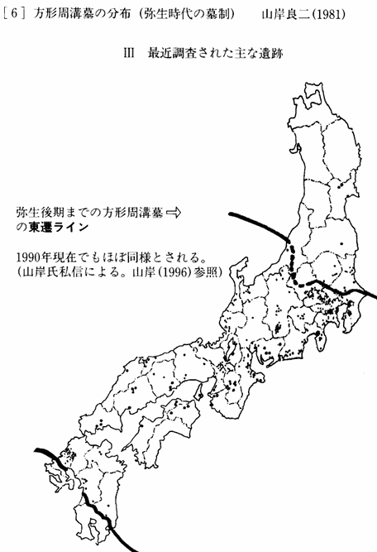

- Map: Distribution patterns of “jatsu” ＜“*jat~”(lesft side) and sawa ＜“*sapa, saba“ (right side)
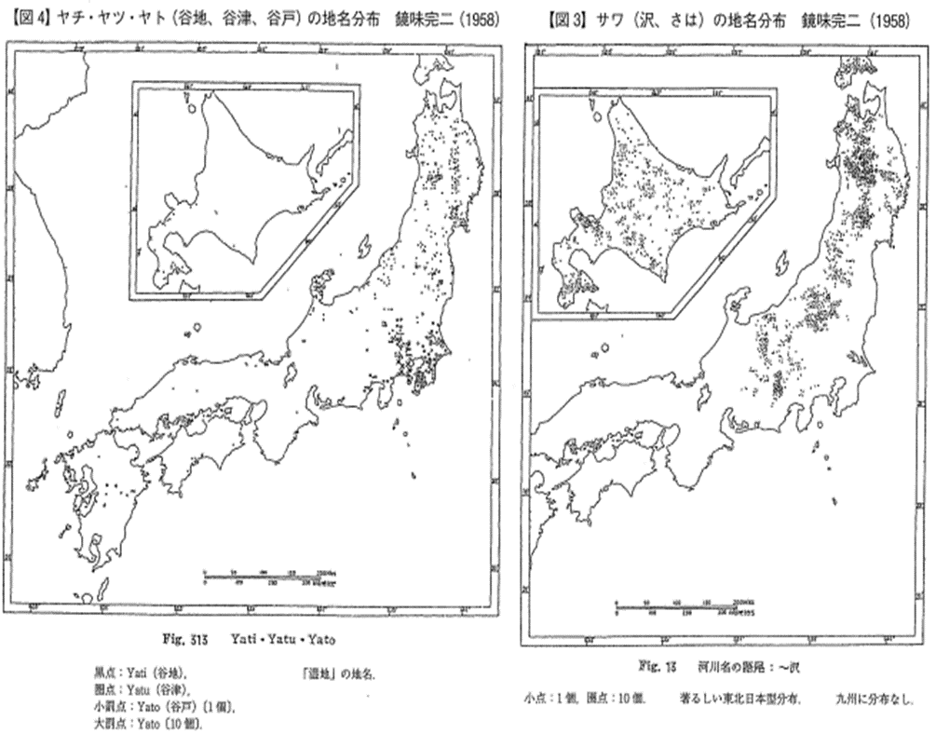
- Map COMPOSIT BORDERS OF LANGUAGES OF LANGUAGES, CULTURE AND CLIMATE IN ASIA (from ABE 2013)
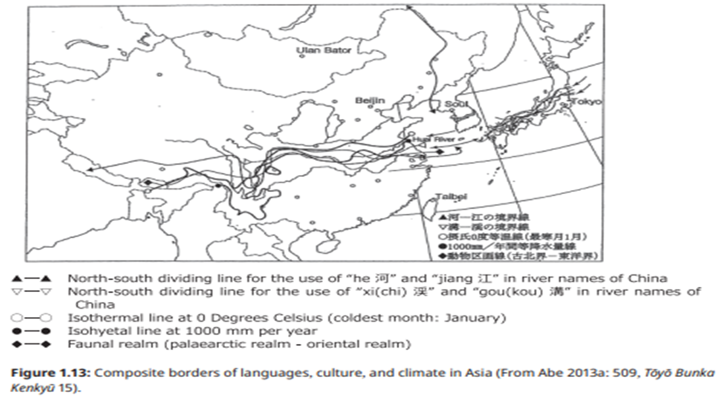
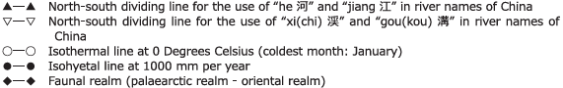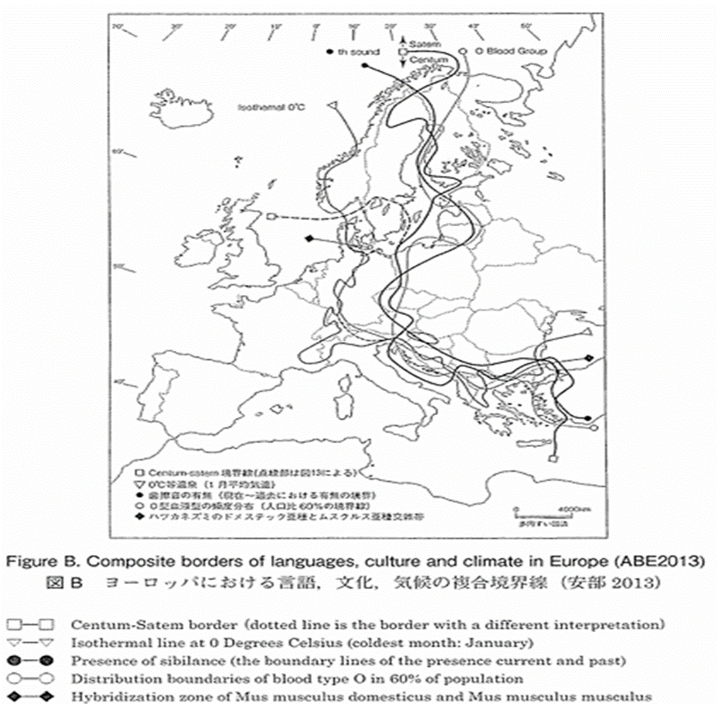

The Scope of Southern Language Influence on Japanese Dialects
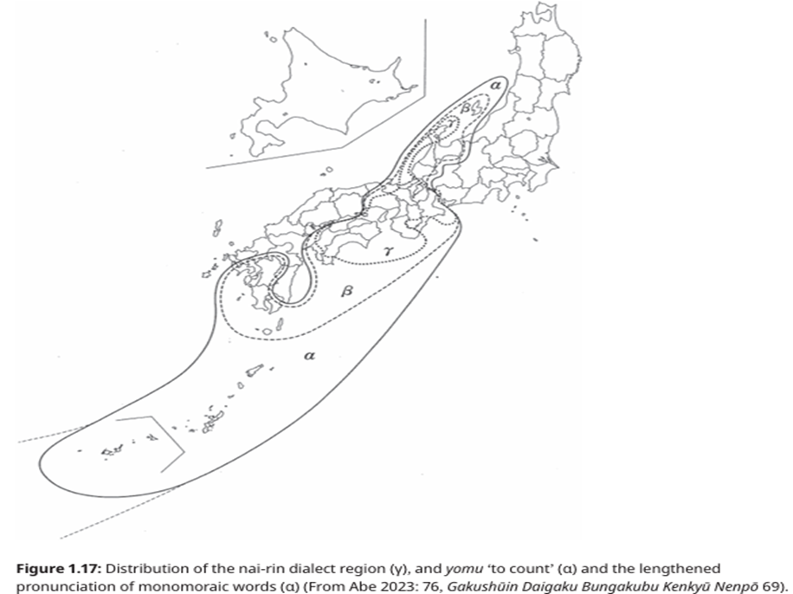： ：：
The Northern Expansion of the Yamato Court: Its Scope and Chronology
